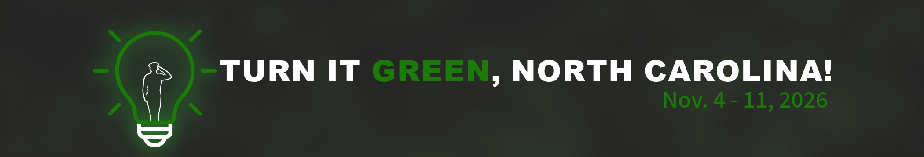
Operation Green Light – Sample Social Media Posts
- [NAME] is joining #OperationGreenLight to shine a light on the service and sacrifice of our Veterans and their families!
As part of #OperationGreenLight for Veterans, [NAME] is illuminating our buildings green from Nov. 4-11,2026, and we encourage individuals and businesses to join us!
With more than 680,000 Veterans calling North Carolina home, shining a green light is one way we show them they are seen, appreciated and supported.
This #VeteransDay, join us in shining a light of hope and support to our Veterans.
- We’re excited to share that [NAME] is joining organizations & businesses across the nation by participating in #Operation Greenlight for Veterans!
[NAME] is illuminating our buildings green from Nov. 4 through Nov. 11! We encourage our neighbors and businesses to join us by switching exterior light bulb at your home or business to a green one. By shining a green light, we show our Veterans that they are seen, appreciated, and supported.
- Join us in honoring 680,000+ Veterans who call North Carolina home by turning your lights green as part of #OperationGreenLight.
Beginning Nov. 4, [NAME] is illuminating its buildings green leading up to #VeteransDay.
By shining a light of hope and support, we will let Veterans know that they are seen and appreciated.
- Let’s celebrate #American250 by shining a light of hope and support on the service of our Veterans during the #OperationGreenLight in the week leading up to #VeteransDay.

- This #VeteransDay, join [NAME] in shining a light of hope and support for our Military and Veterans communities.

- Join #OperationGreenLight and let’s turn North Carolina green for our Veterans.

